Honors Science (Physics) Name:
The Effect of Inertia
Purpose: Investigate inertia, weight, and mass.

Materials: Block of wood with screw eyes attached, Thread, Pencil

Observatons: Be sure to record your observations and results for each section of
this lab in a data table you construct

Don’t be a Block Head…
a.) Tie a piece of thread on one screw eye of the wood block and the other end to the pencil.
b.) Tie another piece of thread to the other screw eye which is attached to the
block. Suspend the block of wood from the pencil. The thread should be barely strong enough to support the object when it is suspended.
c.) Holding the pencil, raise the entire setup above the table (see Figure A). Have your partner pull slowly and steadily on the bottom string until one of the pieces of thread breaks. Be sure that a string did not just come untied. Record which string broke and repeat this process two more times.
d.) Using the same setup shown in Figure A, grasp the bottom thread, but this time give it a quick jerk rather than a steady pull. Repeat the procedure for a total of 3 times. Record which string broke.
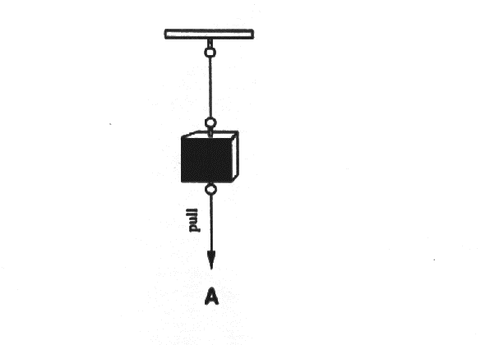Figure A
Support Bar
Data & Observations

(show your observations to your instructor BEFORE moving on…)
Analysis
1.) Different strings break depending on how it is pulled. Explain this from a physics standpoint.

2.) If a massive object, such as a blacksmith's anvil or a cement block, is placed on the stomach of a person lying on the floor and a second person strikes the anvil hard with a sledge hammer, the reclining person is unhurt. However, if the anvil were not on the stomach, the person would certainly have been injured by the blow. Explain.

3.) Imagine you are in deep space holding a large boulder in your hands. You would find it quite difficult to move this boulder even though it has no weight. Explain.

Linear Inertia:

Purpose: Investigate linear inertia

Materials: 3 x 5 card 6 pennies Plastic cup

Procedure:
Part I:
1.) Place a 3x5 card over the mouth of the plastic cup.
2.) Place a coin on the center of the card.
3.) Your goal is to get the coin in the glass without lifting the card.
4.) Try pulling the card slowly.
5.) Try flicking the card with your finger in a horizontal direction and record
your results.

Part II:
1.) Make a stack of five pennies on a smooth flat surface.
2.) Place another penny on the surface a short distance away.
3.) Use your finger to quickly flick this coin against the stack.

Record your observations:

Part 3: A Penny for You Thoughts…

Observations

Analysis

1.) How did you get the coin in the glass? Explain why one method was successful and the other was not.

2.) Explain what occurred when you flicked a coin at the stack of coins.

3.) When you tear a paper towel from a roll which is suspended on a roller, you make a sharp jerk rather than a slow pull. Why?

4.) How do you use inertia to get the last bits of catsup out of the bottle?

